|  |
| --- |
| Software Development Team |
| Let’s Quiz |
| Elaboration Phase Status Assessment |

|  |
| --- |
| Collin McKeahnie |

Contents

1 What is expected to be delivered? iv

2 Why we are developing this application vi

3 What is the CCRD vi

3.1.1 Register vii

3.1.2 Login vii

3.1.3 Answer Question vii

3.1.4 Submit Score vii

3.2 System qualities vii

a) External interface requirements (Non-functional requirements) – viii

i) Usability viii

ii) Reliability viii

iii) Performance viii

iv) Supportability viii

v) Security viii

b) System Constraints viii

c) Assumptions and dependencies ix

4 How we intend to achieve this project ix

4.1 Evidence of competency x

4.2 Risks xi

4.3 Overall Progress xi

# What is expected to be delivered?

We are developing a multiplayer mobile quiz game called Let’s Quiz. The game will be playable on both Apple and Android mobile devices, with single player and multiplayer modes.

The basic operation of the game will be for players to sign in, using either a bespoke Let’s Quiz account or a compatible social media account, then they will play a short quiz game where they are asked a series of multiple choice questions. The player will select the answer they think is correct and will be scored depending if they answered correctly, 10 points for correct answers and -5 points for incorrect answers.

This process of question and answer will continue, with the player being asked new questions until the round timer has run out, at which point the round will end. Once the round has ended the player’s score will be recorded and if it is a personal best added to the global score board.   
At this point the game will be stored in the players ‘on going games’ list where they can return to take their turn after their opponent has finished their turn. The other player will then be notified it is their turn to play a round and they can log in and take their turn, this process will repeat until each player has played three rounds. A round winner is determined from the person who scored the highest that round and the game winner is determined from the person who won the most rounds out of three.

The application is designed to be compatible with Apple and Android smart phones, the client has requested the application be sleek and simple in its design to allow for ease of use. The public facing front end of the application will be a simple interface with a fast paced, colourful, text-based quiz game, designed and built using the Unity3D game engine. The back end will consist of an FTP server communicating with a MYSQL database via PHP scripts.

The intention is to have a highly competitive game that incites players to want to play more to become better. The goal is also to have a community driven application and many of the needs are to encourage user participation in creating and maintaining the question pool.

Some key features of Let’s Quiz are listed below as well as their planned implementation dates, the later items are goals that may or may not be part of the initial release depending if time allows.

|  |  |  |
| --- | --- | --- |
| **Need** | **Feature** | **Planned Release** |
| Playable Quiz Game | Basic single player quiz game that asks a user questions and scores correct answers. This should be playable on an IOS and android mobile device. | April 2018 |
| User Accounts | Users can create an account using the Let’s Quiz app. Users can then sign into the app using that account | April 2018 |
| Guest Accounts | All users to use the application in a limited way without signing in. | June 2018 |
| Question pool that can be updated by users | Allow users to submit questions to the online question pool via an in-app submit question scene where user’s trivia questions are entered and uploaded to the server. | May 2018 |
| Global Score board containing all users | Have a high scores page that syncs with a high scores table on the Let’s Quiz server | May 2018 |
| Ability for users to vote on questions they like or do not | Optional button available to the user at the end of the quiz that increments a rating held against each question on the server | July 2018 |
| Offline redundancy | Should the application not be able to connect to the internet it should pull locally stored data to allow for game play with some reduced functionality | July 2018 |
| Multiple categories of questions | User option to select a specific category of questions before the game, so the quiz is on a topic of interest to the user | September 2018 |
| Multiplayer Quiz Game | Connect 2 users together so they can play against each other. | September 2018 |
| Allow user to have multiple games running simultaneously | Have game management page where users can see and join all their outstanding games | September 2018 |
| Have users play multiple rounds against each other making up a complete game | Ongoing games management for each user, to be handled on the server. | September 2018 |
| Link Let’s Quiz with popular social media platforms | Integrate Let’s Quiz with Facebook and Google Play’s APIs | September 2018 |
| Notify users when it is their turn to ensure faster game play | Push notifications to user’s phones to alert them when it is their turn. | September 2018 |
| Polished game, globally available | Publish Let’s Quiz to Apple’s App Store and Google’s Play Store | October 2018 |
| Picture based questions | Questions could be based off pictures as opposed to text only | TBA |
| Allow for user input as an answer | Ask open ended questions and have users provide an answer as opposed to selected from a multiple-choice list | TBA |

# Why we are developing this application

The client has identified an existing need in the market for an online, multiplayer, mobile quiz game. Specifically, the need that has been identified is to move away from the general, nonspecific quiz games that appeal to a broad market and aggressively target one specific market, in this, case Sci-Fi and Fantasy enthusiasts.

Currently there are several quiz game apps available that have similar features to the proposed project, however the client believes that an app that specifically targets Sci-Fi fandom will have a large enough appeal while being specific enough to be unique to ensure the development of the project is viable.

The development team is proposing *Let’s Quiz*, an online mobile game where players can verse one another in a multiple-choice, turned based, trivia game. The app aims to be community driven with players being able to submit questions and given the chance to vote and rate questions at the end of every round, the intention is to give players a sense of ownership of the game as their own likes and dislikes are what shape the game.

The following needs have been identified as critical for the app to have any chance of commercial success. Easy to use, fast playing, multiplayer, and playable on iOS and Android mobile devices. Given that the idea of a trivia game, playable on a mobile device is not unique it is crucial that Let’s Quiz meets these needs, failure to do so will mean users will simply give up on the app and move on to a competitor.

The proposed product has several points of distinction from its competitor, however the primary reason users will want to play Let’s Quiz over the competition is because it is fun. Where other quiz games test a user on general knowledge, like naming capital cities or remembering obscure dates in history. Let’s Quiz focus is a trivia game about the things its users do in their spare time, movies they watch, comics they read, computer games they play. Let’s Quiz is designed to reward users for the time they spend immersed in their favourite fantasy world.

# What is the CCRD

The critical use case that has been identified is to have a user be able to create a Let’s Quiz account and log in to the game, to be able to play a game and then to have their score recorded on the global score board.

These use cases cover all the necessary architecture for the entire system to be realised. At this stage of development, we have produced a working model to demonstrate the CCRD to the client, as well as supporting documentation.

These use cases are completely expanded in the Requirement Model document and are listed below:

* Register
* Login
* Answer Question
* Submit Score

## System qualities

We have outlined the system qualities needed to achieve these use case also in the Requirement Model. These can be summarised as follows:

**Usable**: The game must be inherently easy to use

**Reliable**: It must work first time, every time. This includes the user interface and all aspects of the back end

**Fast:** In terms of response time the game must be very fast, also in terms of game time the run through time must also be fast.

**Secure**: Let’s Quiz is designed to be personalised for each player, with user stats and game states that must be remembered, to do this we have used different account and also the option to link with user’s social media accounts. Any information the user shares with us must be kept secure.

## Activity Diagram for CCRD

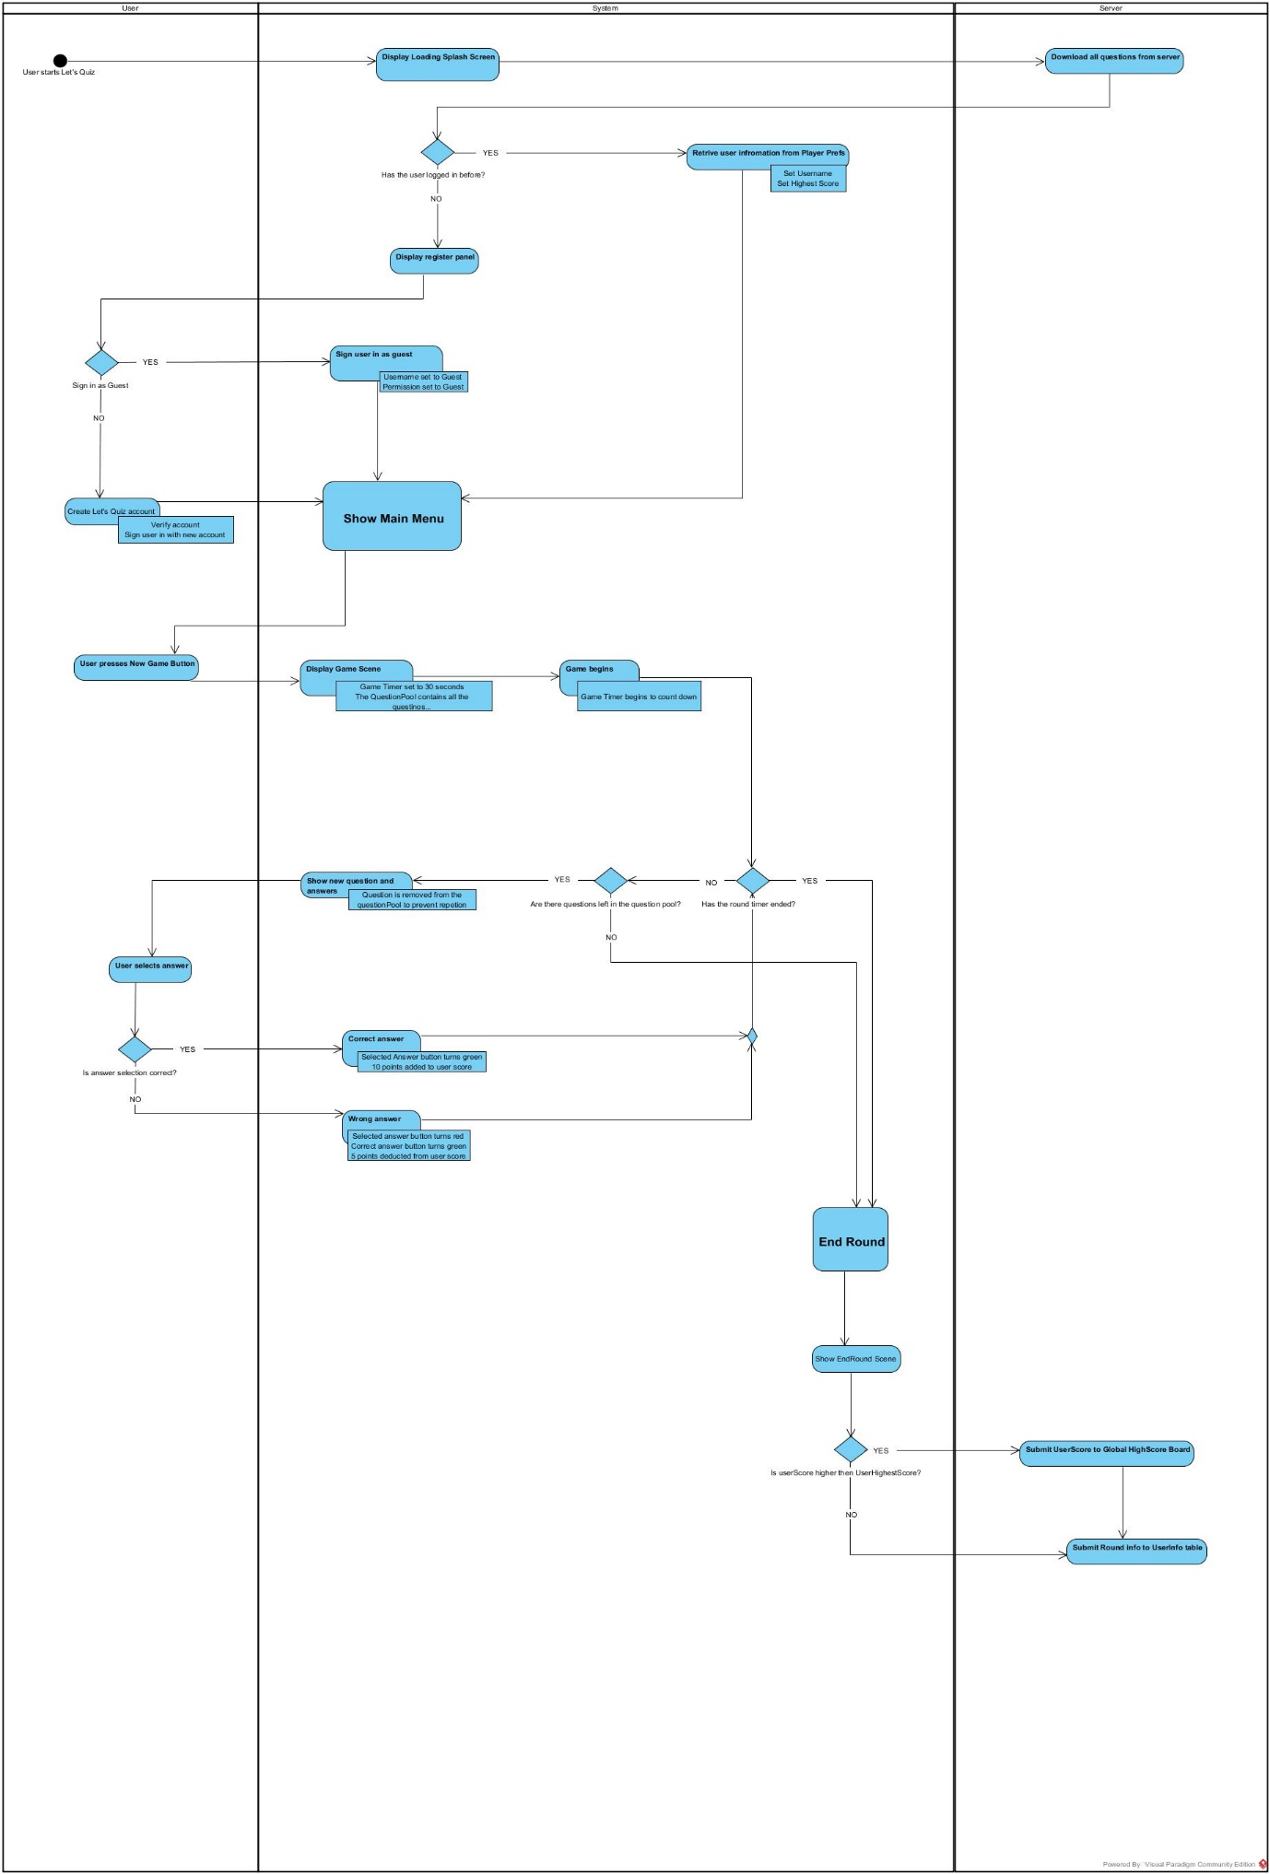

# How we intend to achieve this project

Essentially the plan moving forward so to expand the application submitted to the point where it is the final product.

We plan to continue using iterations where specific project goals and critical software infrastructure will be implemented. Each iteration will be a minimum of two-week blocks but can be longer depending on the tasks assigned. Each iteration will have its own unique plan, where the requirements are outlined, and tasks are assigned to team members. Each member is responsible for updating the iteration plan documenting their progress on their assigned task, however during each iteration meeting their progress will be updated if not done so already.

As outlined in the project plan we are on track with our iteration goals and provided we continue to remain so shouldn’t have a problem delivering the project on time.

An abbreviated copy of the project plan is as follows with everything up to an including E-4 having been achieved.

## Evidence of competency

The purpose of submitting this technical competency demonstration is to show that as a development team we can execute all aspects of the architecture.

The application as submitted is designed to give a realistic feel for how the final product will look and feel. At this point the look and layout of each scene in the game is essentially finished. The application allows for users to create an account and then sign in to the application using that account or skip the process all together and play as a guest. What we feel we have shown here is that we can create user tables, maintaining a user state after they exit the application and that the application is able to run with varying degrees of permissions depending on the manner the user has signed in. The final product requires merely an extension of this sign in process by adding two new methods of verification, Facebook and Google Play.

The quiz game itself functions identically to how the final product’s single player quiz game will operate, including the round timer and scoring, question tracking and score submission. This is a large part of the architecture that has now been completed.

Submit Question and the global high score board are also fully functional parts of the demonstration application. For all intent and purpose these scenes are also finalised and ready for the finished product. There are of course small things that may need to be changed or updated as the application grows, for example currently all new questions are submitted with a default category, however functionally they are now complete.

## Risks

At this stage we do not have any overbearing concerns. While initially it is true there were some technical aspects of project we were unsure if we possessed the skills to complete those concerns have all been address and we are now completely confident in our ability to deliver the project as outlined.

## Overall Progress

At this stage the development team is on track with regard to their overall progress goals. They have completed the deliverable outcome of Assessment 3: LCAM and each team member is working towards achieving the other deliverables.

We have a clear business goal as outlined in the Vision document.

We have a good outline of the use cases required and the system qualities we need to achieve, these are outlined in the Requirements Document

We feel confident in our ability to achieve the goals required for the final product by setting realistic iteration goals as outlined in the project plan

|  |  |  |  |
| --- | --- | --- | --- |
| **Business Need** | **Deliverable Functionality** | **Project Plan Task** | **Planned Implementation** |
| Personalised user experience | Users can create an account using the Let’s Quiz app. Users can then sign into the app using that account | User registration and login | Complete |
| Playable Quiz Game | Single Player Game | Single player playthrough | Complete |
| Community driven question list | Question pool that can be updated by users | **Submit Question** | Complete |
| Ability for users to upvote/down vote questions they like or dislike | Question & Question Submitter leader board | TBA |
| Competitive hook to encourage players to want to get better | Global Score board containing all users, updated after each game | Leader board | Complete |
| Users are able to see how their question is tracking with regard to popularity and other metrics | Question Popularity chart | September 2018 |
|  | Games are made up of three rounds with the winner being the person who won the most rounds | Best of three game style | TBA |
| Rich gaming experience which players will not get bored of easily | Users can choose what category the questions from each round will focus on. Each player will get to pick one round’s topic and the final round will be random | Question Categories | TBA |
|  | Questions can be asked using pictures instead of text only | Picture based questions | TBA |
| Users are able to play when online and offline | Offline single player support | Offline redundancy | TBA |
| Multiplayer Quiz Game | Games can be played against another player from around the world | Multiplayer Playthrough | 23/07/2018 |
| Users can have multiple games running simultaneously | Game Lobby | TBA |
| Link Let’s Quiz with popular social media platforms | Facebook & Google Play | Social Media Integration | 06/08/2018 |
| Notify users when it is their turn to ensure faster game play | Mobile push notifications | Push Notifications | 20/08/2018 |
| Polished game, globally available | Publicly release Let’s Quiz using the App Store and Play Store | Public Release | TBA |